Prof. Ananya Ghosh Dastidar

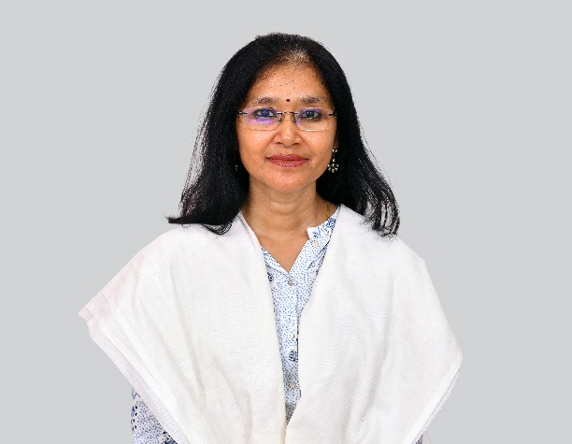
- Degree :- M.A., M.Phil., Ph.D. (C.E.S.P., J.N.U.)

- Subject :- Statistics and Data Analysis, Macroeconomics, Econometrics Methodology, Indian Economics

- Research Interest :- International Economics, Development Economics specially the problems of poverty and income inequalities in Developing countries.

Contact Info
Email : agdastidar@gmail.com

Research Publications

- The Indian Economy : Issues, Policies and Performance - Bhattacharyya R. and Dastidar, A.G. – 2024

https://www.routledge.com/The-Indian-Economy-Issues-Policies-and-Performance/Bhattacharyya-Ghosh-Dastidar/p/book/9781032510637

- “Corona Pandemic, India and the World: Economic and Social Policy Perspectives”, Routledge: London - Bhattacharyya, R., Dastidar, A.G. and Sikdar, S. (Eds.) - September, 2021 - [ISBN 9781032114965]
https://www.routledge.com/The-COVID-19-Pandemic-India-and-the-World-Economic-and-Social-PolicyPerspectives/Bhattacharyya-Dastidar-Sikdar/p/book/9781032114965

- “Transforming India : From Vision to Reality”, Ane Books : New Delhi, 2019.

- Dastidar, A.G., R. Malhotra and V. Suneja (Eds.), “Economic Theory and Policy amidst Global Discontent” - Gupt, Y. and A.G. Dastidar (Eds.)- Routledge: London, 2018

https://www.routledge.com/Economic-Theory-and-Policy-amidst-Global-Discontent/Ghosh-Dastidar-MalhotraSuneja/p/book/9781138689213

- “Contemporary Issues in Trade, Environment and Policy”- Dastidar, A.G. and Y.Gupt (Eds.)- Ane Books : New Delhi, 2016.

- “An Evaluation of Monetary Policy in India : A Sustainable Development Perspective” (co-author Kajleen Kaur) in Dasgupta, P., Roy Saha, A. and Singhal, R. (eds.), ‘Sustainable Development Insights from India’, Springer Nature, pp.107-139 (March, 2021) [ISBN 978-981-334-830-1]
https://www.springer.com/gp/book/9789813348295

- “A Perspective on the Slowdown in Private Corporate Investments in India”, (co-author R. Ahuja) in Bandyopadhyay, S. and Dutta, M. (Eds.), “Opportunities and Challenges in Development”, Springer, 2019.

ResearchGate Profile - https://www.researchgate.net/profile/Ananya-Dastidar-2
Google Scholars Profile - https://scholar.google.com/citations?user=L0ZkUwIAAAAJ&hl=en

More Details - https://drive.google.com/file/d/1vweJvBn5MDZDxgC4ENFlYMsYvM3iepuy/view

